Identificar los elementos HTML (Aside, Header, Nav, Footer, Section, H1, H2, H3, H4, H5, H6)

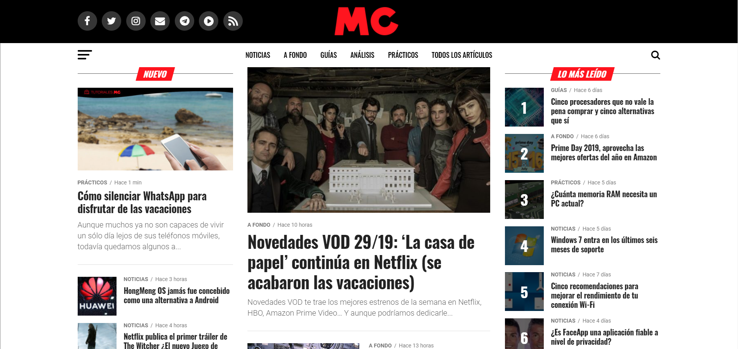

<https://www.muycomputer.com/>



<https://www.genbeta.com/>

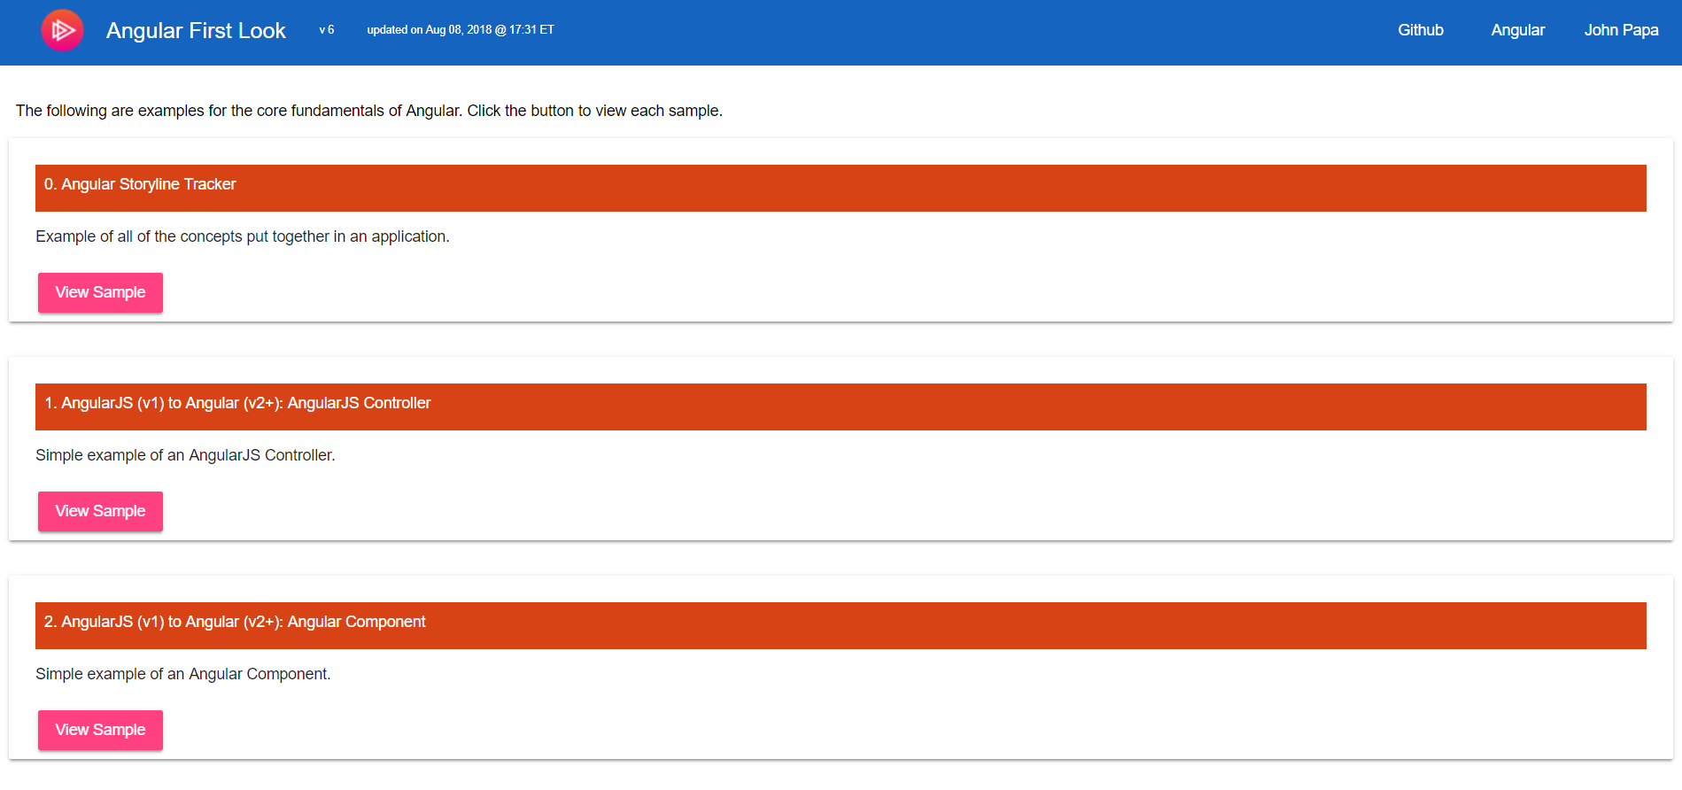

<http://angular2-first-look.azurewebsites.net/>

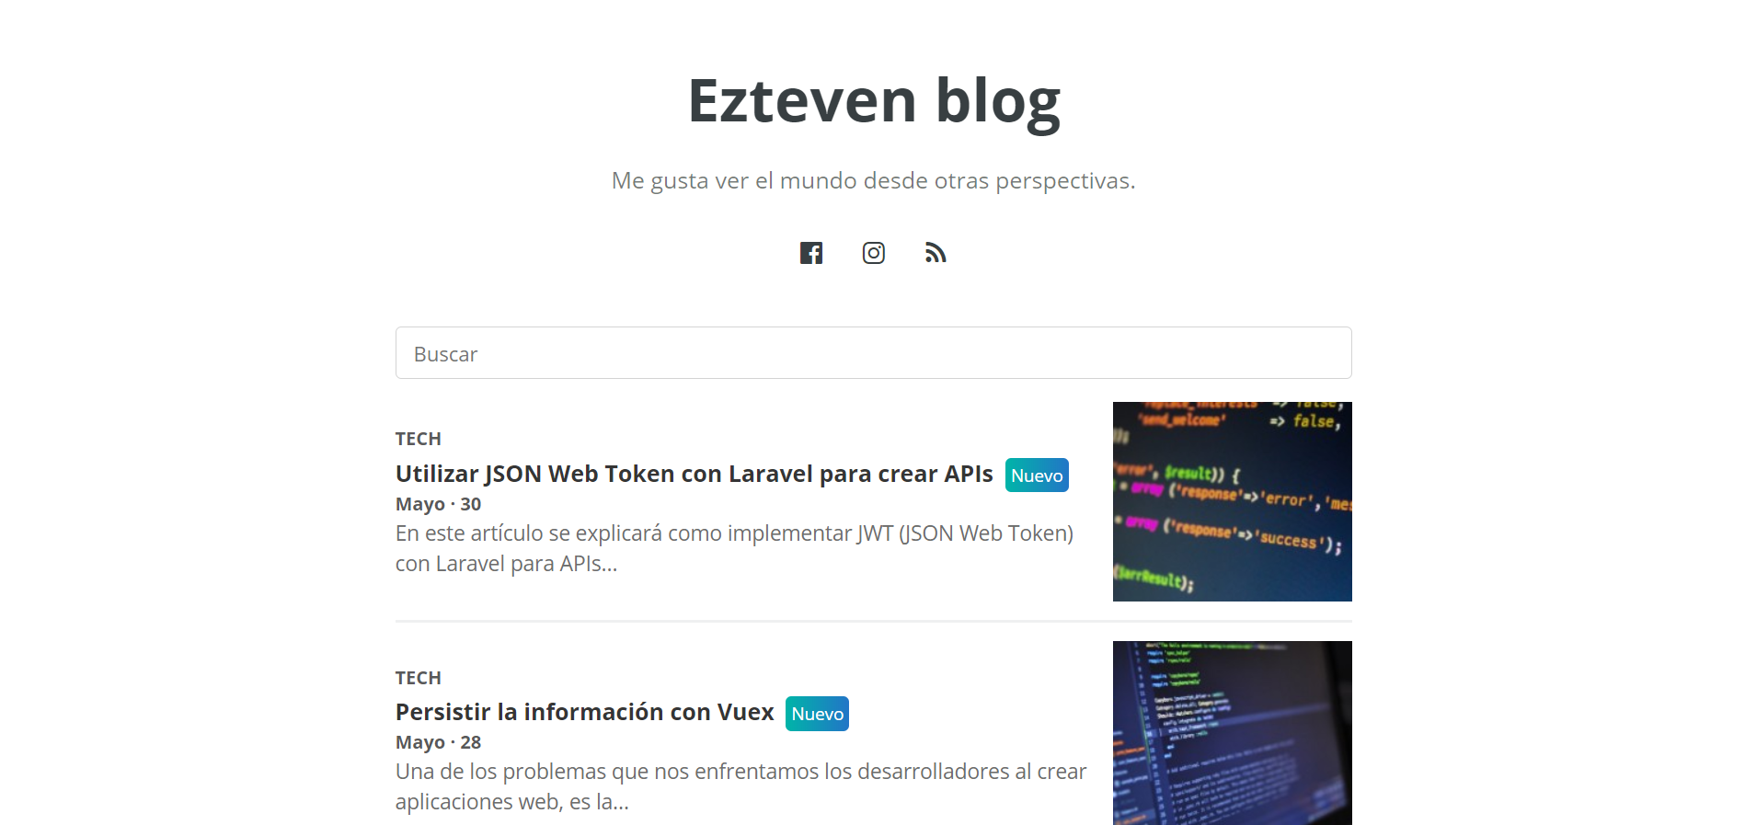

<https://blog.ezteven.com/>